**cCreated by:-** Suraj Chopade **email:-** [srj281191@gmail.com](mailto:srj281191@gmail.com)

------------------------------------------------------------------------------------------------------------------------------------------------------------------------------------

**Apache Name Based Hosting:-**

Hosting multiple sites of different sub-domain with the same port. Considerations are as follows

* **Domain:-**

Nixstock.in

* **Subdomain:-**

app1.nixstock.in

app2.nixstock.in

* **Prerequisites:-**
* RedHat 7 +
* SSL Letsencrypt
* Firewall ports 443 and 80 opened

**Steps:-**

* Install apache with yum package manager and start the service and enable on boot time

# yum install httpd -y && systemctl start httpd --now

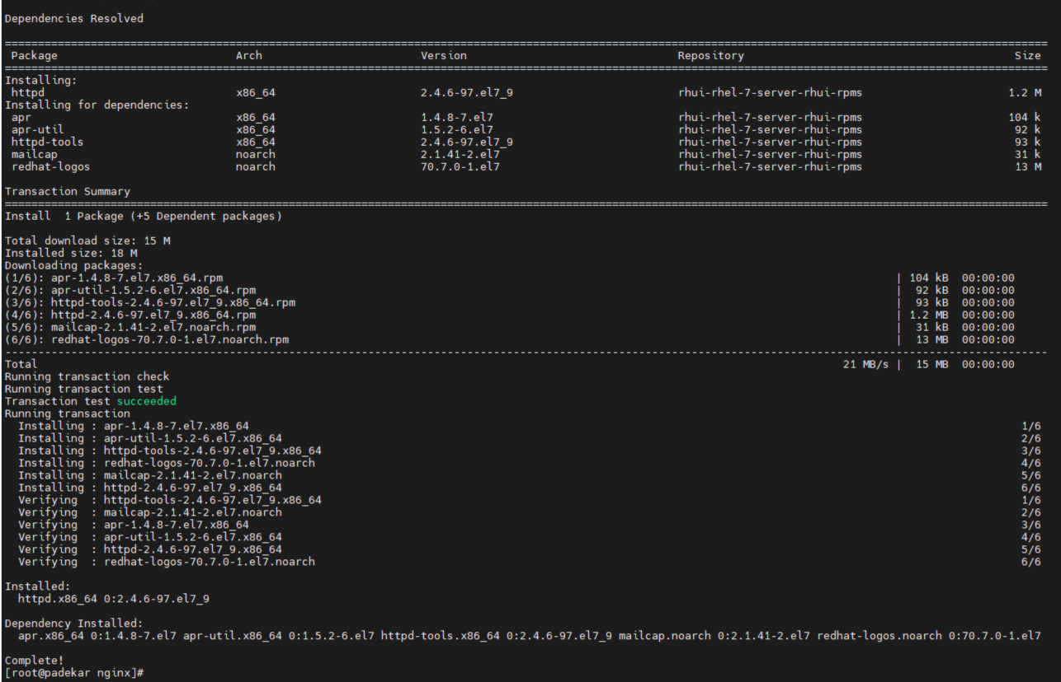

* Create a directory structure in /var/www as /var/www/app1.nixstock.in/html and place index.html file and add following content

# mkdir -P /var/www/app1.nixstock.in/html && cd /var/ww/app1.nixstock.in/html

# vim index.html

<h5> this is app1.nixstock.in </h5>

* Create the same structure for app2.nixstock.in and add content as

<h5> this is app2.nixstock.in </h5>

* Open configuration file /etc/httpd/conf/httpd.conf and add following lines at bottom of file

<VirtualHost *:80>

ServerName nixstock.in

ServerAlias www.nixstock.in

DocumentRoot /var/www/www.nixstock.in/html

</VirtualHost>

<VirtualHost *:80>

ServerName nixstock.in

ServerAlias www.nixstock.in

DocumentRoot /var/www/www.nixstock.in/html

</VirtualHost>

* Restart the service

# systemctl restart httpd

* Test your websites in browser or command line with curl

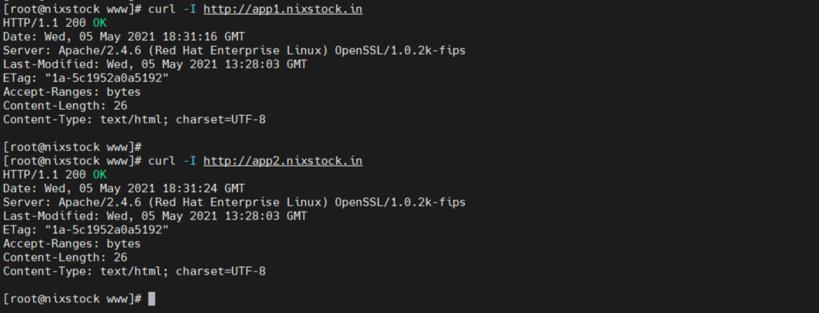

**Applying SSL Certificate:-**

We are using Letsencrypt SSL certificate which will be installed on this server and placed on the website with certbot. Following link will give you steps to install Letsencrypt certificate

<https://certbot.eff.org/lets-encrypt/centosrhel7-apache.html>

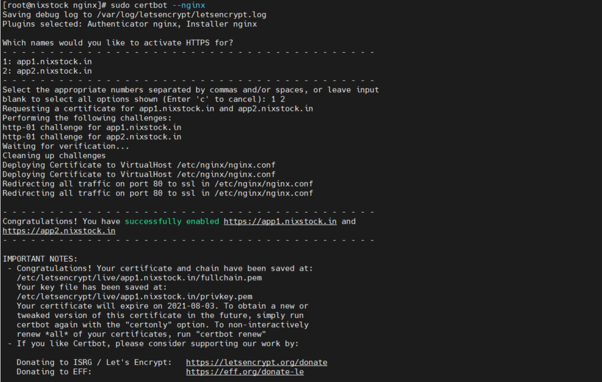

Once the SSL installation is done, you will see following entries mapped with your Virtual host as

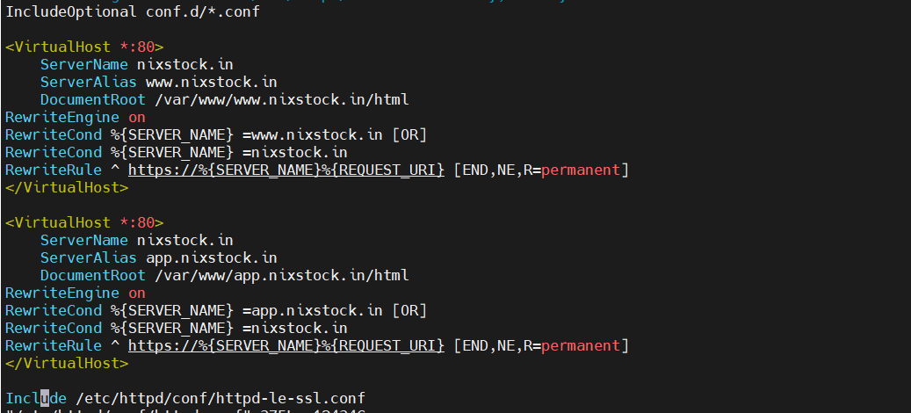

Once SSL installation is completed we can check out websites with https://app1.nixstock.in with browser